Mapping Microglia Parameters Software
Image J Plugin

User Guide

Introduction to Image J Plugins

Mapping Microglial Parameters Software (MMPS) allows for minute, accurate measurements of microglia. However, the built-in calculations address simple characteristics of microglia and leaves significant room for advanced calculations. Image J is a free, open-source software that contains many impressive plugins that can expand upon MMPS. Herein, we describe three general calculation types, jython scripts that will automate the calculations, and how to utilize them.

How to install the plugins:
To run any of the plugins, open Image J (we recommend Fiji) and select plugins to reveal the dropdown menu. After selecting “Macros”, select “Run”.

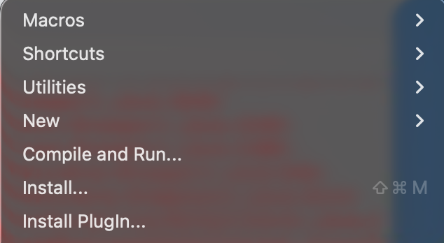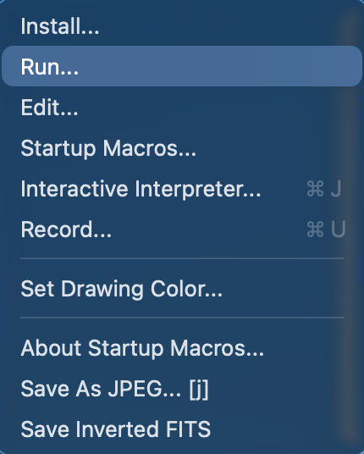
From here, select the script you would like to run. A common error is that Image J is not expecting to read in jython language and instead expects java or Image J Macro, resulting in an error message. If this occurs, click “Edit…” underneath “Run” and open the script. You will now see the script’s coding. At the top menu, navigate to an area called “Language”.

From “language”, ensure that Jython (Python) is selected.

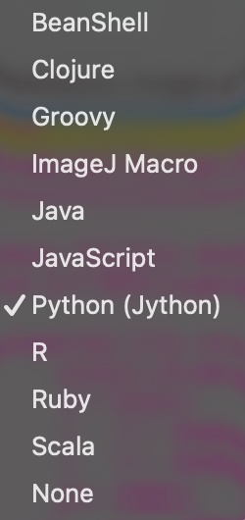
Now, click “Run” in the bottom left of the screen. Notice how it states the active language now as Python (Jython).

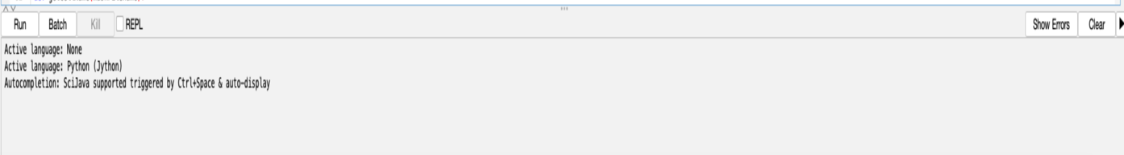

Skeleton Analysis Plugin
The skeleton analysis breaks the mask images down to its “skeleton”. Essentially, it removes all the extra pixels and only keeps lines that connect all the extremities to the soma center. This is a great way to analyze branching patterns in microglia. After opening the SkeletonAnalysisImageJ.py file and running it, a menu will appear that asks for criteria for the calculations. First, “Mask Directory” wants the file directory of the folder named “masks” that has the microglial masks in it. The “Output Directory” wants a folder to save the results. For simplicity, it is easiest to select the “Output” folder from MMPS. Once again, you will be prompted with the pixel size. Make sure to enter the correct size it will determine the accuracy of the results. “Upscale Factor” accounts for magnification differences between imaging. Select 1 for 40x and 2 for 20x. Enter the needed value based on your imaging. “Only analyze the largest mask per cell” checkbox should be selected if you would like to only analyze the largest mask of each cell. This process is time consuming and computationally expensive, thereby selecting this will only calculate the biggest masks of each cell as the smaller masks are likely less accurate than the largest mask is.
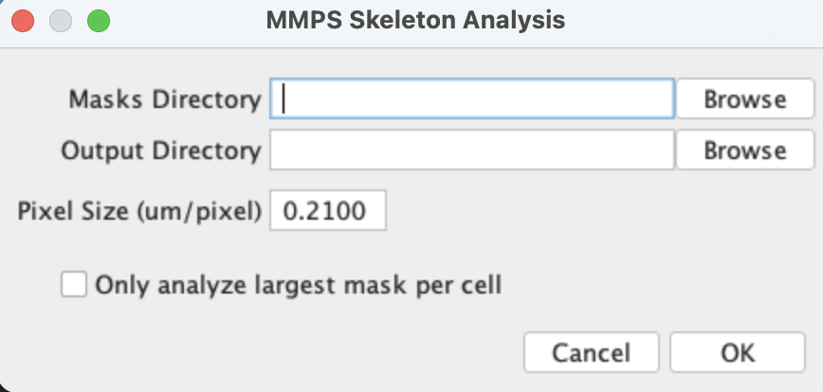
Sholl Analysis Plugin
To begin, ensure SNT (Neuroanatomy) plugin is installed as their Sholl program will be utilized. This comes default with Fiji but not basic Image J. Sholl analyses can be complicated, but essentially, they map a cell (such as a neuron) with many concentric rings and determine where the cell cross the rings. After opening the Sholl.py file, the “MMPS Output Folder” wants the MMPS output folder you created when running MMPS. For simplicity, it is easiest to select the “Output” folder from MMPS. Once again, you will be prompted with the pixel size. Step size indicates at what distance from the soma you would like to sample for the concentric ring generation. “0.0” is the default and offers continuous sampling and is recommended to use. “Use soma radius as start radius” checkbox indicates if you already have a soma selected which if the MMPS was used as described, you already do. If you do not select that, you must indicate your sampling distance. Again, “Only analyze the largest mask per cell” checkbox should be selected if you would like to only analyze the largest mask of each cell.
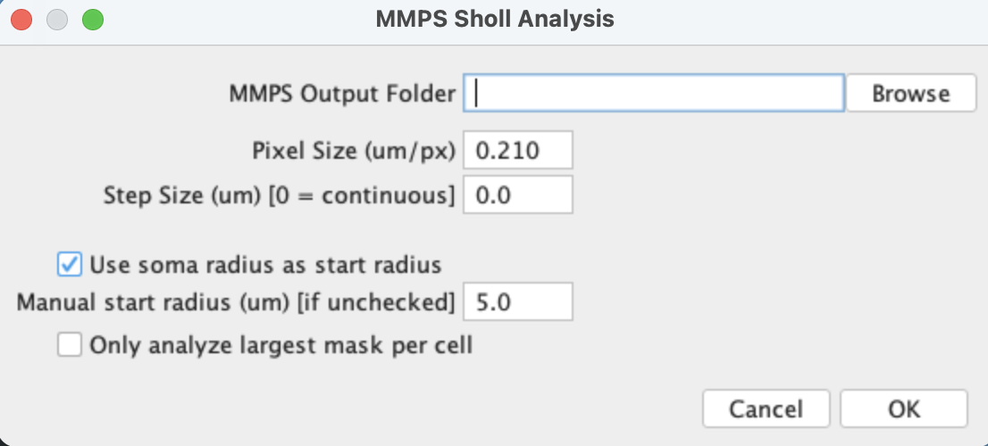

NOTE: The Sholl analysis is the longest calculation of all three plugins. If speed is critical, consider utilizing this plugin on computers with stronger GPUs or CPUs. An effective solution is to also distribute the calculations by animal or image onto their own cores i.e. many different processors run a few images concurrently versus one processor runs them all in order of the folder. The Fiji tool also has known quirks that can lead to “NA” results if it stalls in its calculations. To overcome this, ensure enough cells are submitted or attempt larger sampling step sizes.

Fractal and Hull Analysis Plugin
Fractal and hull analysis utilize the placement of boxes inside the cell mask to analyze cell characteristics. To begin, open “FractalAnalysis_ImageJ.py”. This is the simplest of the three sets to run as it only requires the “MMPS Output Folder” as we discussed earlier, the pixel size, and large mask calculation.

